ORTHOPAEDIC INSTRUMENTS
Basic Instruments for Small & Large Bone Plating
Bone Tap
Intended Use
The bone tap for small and large bone plating is a cortical thread-cutting instrument used prior to screw insertion in fracture fixation of medium and large bones. It creates precise internal threads matching standard cortical or locking screws (3.5 mm, 4.5 mm) to maximise pull-out strength in large animal orthopaedic and canine long bone fracture repair. | 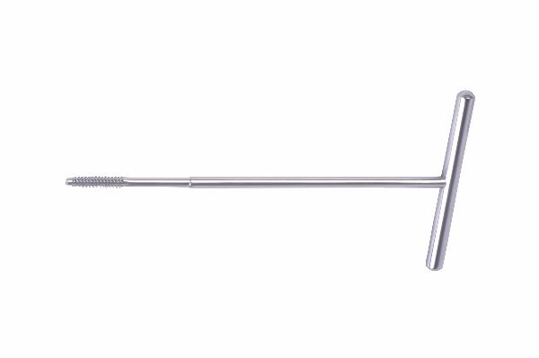
Function
Hardened fluted cutting edges on the tap shank shave cortical bone as the instrument is rotated clockwise by T-handle. Back-cutting flutes clear bone chips from the emerging thread, preventing jamming. The precisely controlled pitch and diameter produce threads that engage the full screw thread profile for maximum interfragmentary compression.
Advantages
Maximum Screw Purchase: Pre-tapped threads align perfectly with the screw pitch, achieving maximum bone-screw contact area and pull-out resistance — especially important in load-bearing large breed dog fractures where cyclic forces are extreme.
Reduced Cortex Splitting Risk: Removing bone material before screw insertion avoids the wedge-splitting force of self-tapping screws in dense cortical bone, protecting thin cortex fragments from iatrogenic fracture during fixation.
FAQ
Q: What screw sizes require a bone tap in large bone plating?
A: 3.5 mm and 4.5 mm cortical screws typically require pre-tapping in hard cortical bone; self-tapping variants are available but pre-tapping remains the gold standard in dense diaphyseal cortex.
Q: How do I know when the tap has cut through the far cortex?
A: Resistance suddenly drops as the tap exits the far cortex; stop advancing at this point and reverse-rotate to withdraw, then measure depth and select the appropriate screw length.

ORTHOPAEDIC INSTRUMENTS
Basic Instruments for Small & Large Bone Plating
Broken Screw Removal Forceps
Intended Use
Broken screw removal forceps are specialised retrieval instruments used to extract fractured orthopaedic screws embedded in bone during revision plating surgery. They are critical salvage instruments for implant removal when standard screwdrivers cannot engage the damaged screw head in veterinary and large animal fracture repair. | 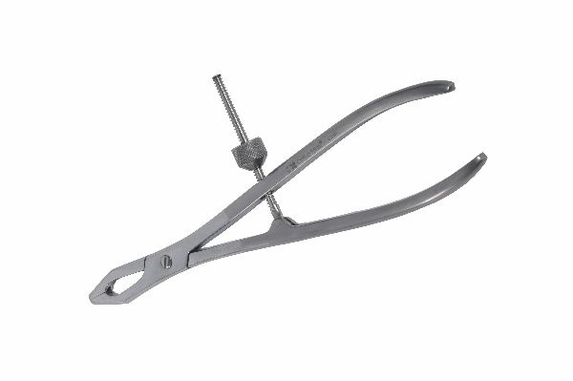
Function
The forceps carry hardened, serrated conical tips that grip the broken screw stub projecting from the bone surface. The ratchet handle applies progressive gripping force, allowing the surgeon to rotate and back-out the broken fragment using a combined grip-and-torque action without enlarging the bone defect unnecessarily.
Advantages
Minimises Bone Loss During Retrieval: Precise conical tip engagement retrieves broken screws without requiring large trephine extraction, preserving cortical bone stock for re-fixation with new implants in the same surgical setting.
Handles Recessed Breaks: Even screws broken below the plate surface can be retrieved by engaging the stub within the plate hole, eliminating the need for hollow-mill counterboring in many cases.
FAQ
Q: What if the broken screw stub is flush with or below the bone surface?
A: A hollow mill is used to expose the stub, which is then engaged by the forceps; alternatively, a screw extractor drill-bit system may be required for deeply recessed fragments.
Q: Are these forceps reusable?
A: Yes, provided the serrated tips are inspected before each use; worn or deformed tips lose grip on the screw stub and may cause the fragment to spin freely, complicating retrieval.

ORTHOPAEDIC INSTRUMENTS
Basic Instruments for Small & Large Bone Plating
Counter Sink
Intended Use
The counter sink is a bone preparation instrument used to bevel the cortical bone opening of a drilled screw hole so that the screw head seats flush with or below the bone surface. It is used in small and large bone plating to prevent screw head prominence and periosteal irritation during fracture healing. | 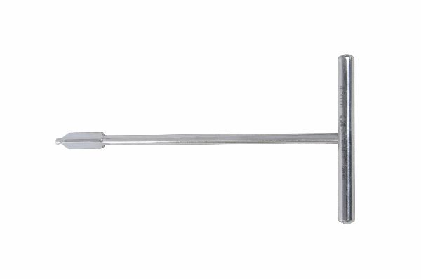
Function
The conical fluted cutting head, matched to the screw head taper angle, is inserted into the drilled hole and rotated to remove a thin ring of cortical bone. This creates a recessed seat that allows the screw head underside to engage bone rather than sitting proud, eliminating the lever arm that causes screw toggling.
Advantages
Flush Implant Profile: Countersinking eliminates screw head protrusion above the bone surface, reducing soft tissue irritation, periosteal stripping and palpable implant discomfort in thin-skinned small animal patients post-operatively.
Enhanced Screw Head Purchase: The bevelled seat increases the bone-contact area under the screw head, distributing compressive load over a wider area and reducing the risk of head pull-through in osteopenic or cancellous bone.
FAQ
Q: Is counter sinking always required in bone plating?
A: It is optional for standard cortical screws but is recommended for lag screw technique and in any bone region where screw head prominence would cause soft tissue or implant complications.
Q: What angle is the countersink cone?
A: The cone angle matches the underside of the screw head — most orthopaedic cortical screws use a 60° or 82° head taper, and the counter sink must be angle-matched to the screw system.

ORTHOPAEDIC INSTRUMENTS
Basic Instruments for Small & Large Bone Plating
Depth Gauge with Laser Scale
Intended Use
The depth gauge with laser-engraved scale is a precision measurement instrument used in small and large bone plating to determine optimal screw length after drilling. Laser markings provide high-visibility, wear-resistant graduations that remain legible through repeated sterilisation cycles in busy veterinary and human orthopaedic surgical theatres. | 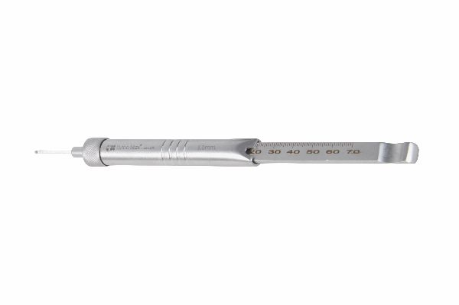
Function
The hooked distal tip is passed into the drilled hole and engaged against the far cortex. The calibrated sliding indicator is pushed down to the near cortex, and the laser-engraved millimetre scale on the shaft is read to give exact bone thickness. Screw length is then selected to match or slightly exceed the measured depth for bicortical purchase.
Advantages
Permanent High-Visibility Markings: Laser engraving creates deep, recessed graduations that resist abrasion from sterilisation trays and autoclaving, ensuring accurate readings remain readable throughout the instrument's clinical lifetime.
Dual-Cortex Measurement Accuracy: The hook tip reliably catches the far cortex even in cylindrical or irregular medullary canals, giving accurate depth readings that prevent screw selection errors in weight-bearing long bone constructs.
FAQ
Q: How does the laser-scale gauge differ from a standard depth gauge?
A: Laser-engraved scales are permanently recessed into the steel, resistant to steam and chemical sterilisation whereas printed or etched markings can wear or become illegible over time.
Q: What is the measurement range?
A: Gauges for small and large bone plating typically range from 10 mm to 80 mm, covering screw lengths used across canine femur, tibia, humerus and radius plating procedures.

ORTHOPAEDIC INSTRUMENTS
Basic Instruments for Small & Large Bone Plating
Drill & Tap Sleeve – Double Ended
Intended Use
The double-ended drill and tap sleeve is a combination guiding instrument used in small and large bone plating that provides both drill guidance and tap protection in a single reversible tool. It reduces instrument count and operative time in fracture fixation procedures requiring sequential drilling and tapping of cortical screws. | 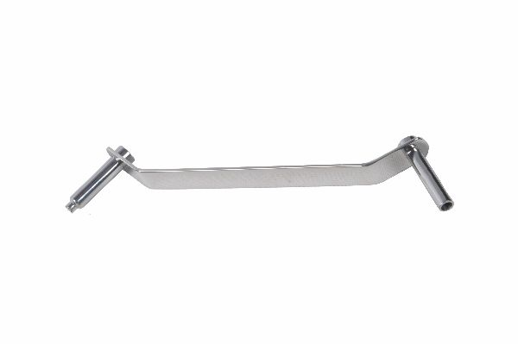
Function
One end carries the drill bore matched to a specific screw core diameter; the other end accepts the corresponding bone tap. After drilling with the drill-end seated in the plate hole, the sleeve is reversed to guide the tap centrally and perpendicularly into the newly drilled hole, ensuring co-axial thread formation.
Advantages
Single Tool, Two Functions: Combining drill and tap guidance in one instrument reduces instrument count on the trolley, decreases the risk of wrong-sleeve selection errors, and speeds the screwing sequence in multi-hole plate constructs.
Guaranteed Co-Axial Alignment: The sleeve bore ensures the tap follows exactly the same axis as the drill, producing threads centred in the hole and preventing the tap from deviating and cross-threading, which would require re-drilling and re-tapping.
FAQ
Q: Are double-ended sleeves system-specific?
A: Yes. Each sleeve is designed for a specific screw diameter and must match the implant system; mixing sleeves from different systems risks off-axis drilling and poor screw engagement.
Q: How is the correct end identified quickly during surgery?
A: Most double-ended sleeves are laser-marked with drill and tap symbols and the corresponding diameter at each end, allowing rapid identification under theatre lighting.

ORTHOPAEDIC INSTRUMENTS
Basic Instruments for Small & Large Bone Plating
Drill–Screw–Wire Gauge Scale
Intended Use
The drill-screw-wire gauge scale is a multi-function measurement instrument used to verify the diameter of drill bits, orthopaedic screws and K-wires during small and large bone plating procedures. It prevents size selection errors that can compromise fracture fixation constructs in veterinary orthopaedic surgery. | 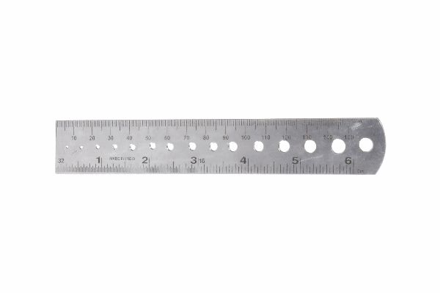
Function
A series of graduated stepped holes or slots in a hardened stainless steel plate allows the user to slide drill bits, screws or wires through progressively sized openings. The smallest hole that the instrument passes through freely indicates its precise diameter, confirming correct size selection before use.
Advantages
Eliminates Size-Mix Errors: Visually similar drill bits, wires and screws can be misidentified under theatre lighting. The gauge provides objective physical verification, preventing the potentially catastrophic use of a wrong-diameter drill that creates an oversized hole reducing screw purchase.
Instrument Set Integrity Check: Pre-operative gauging verifies that all instruments returned from sterilisation are correctly matched to the implant tray, identifying any substitution errors that could interrupt surgery.
FAQ
Q: Can the gauge be used for both metric and imperial sized instruments?
A: Most veterinary orthopaedic gauges are metric (mm) to match AO/ASIF implant systems; imperial equivalents exist but metric remains the global standard for bone plating instrumentation.
Q: How accurate is the gauge measurement?
A: Precision gauges are accurate to ±0.05 mm, sufficient to differentiate between adjacent standard sizes such as 2.5 mm and 2.7 mm drill bits that look almost identical visually.

ORTHOPAEDIC INSTRUMENTS
Basic Instruments for Small & Large Bone Plating
Drill Bits – S.S. for Hand Drill
Intended Use
Stainless steel drill bits for large bone hand drilling are high-precision cutting tools used to create pilot holes for standard cortical and locking screws in medium and large breed dog and cat fracture repair. They are matched to 3.5 mm and 4.5 mm screw systems used in small and large bone plating. | 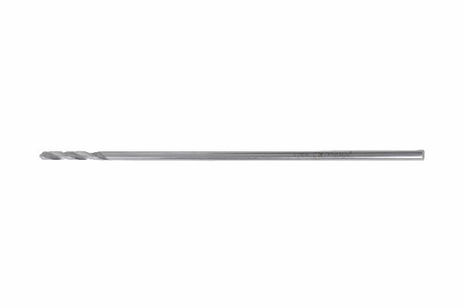
Function
Two-flute or three-flute helical geometry with sharp, hardened cutting tips shear cortical bone cleanly under hand-drill power. The flute geometry efficiently evacuates bone chips from the hole, maintaining cutting efficiency and reducing heat generation in dense diaphyseal cortex.
Advantages
Matched to AO Screw Systems: Bit diameters are precisely matched to the core diameter of corresponding AO cortical screws, ensuring accurate thread engagement and the correct pull-out strength specified for each screw size in large bone applications.
Reusable and Autoclavable: All-stainless construction with no polymer components allows unlimited autoclave cycles at 134 °C, making these bits economical consumables when maintained with regular sharpness inspection.
FAQ
Q: What sizes are included in a small-large bone plating drill bit set?
A: Typically 2.5 mm, 3.2 mm, and 4.5 mm bits corresponding to 3.5 mm cortical, 4.5 mm cortical, and 6.5 mm cancellous screw core diameters respectively.
Q: How do I know when a drill bit needs replacement?
A: Increased resistance during drilling, squealing sound, or visible tip dulling under magnification all indicate replacement; dull bits increase cortical crack risk and thermal necrosis.

ORTHOPAEDIC INSTRUMENTS
Basic Instruments for Small & Large Bone Plating
Drill Sleeve for DCP – Centric & Eccentric
Intended Use
The DCP drill sleeve is a positioning instrument used with dynamic compression plates (DCP) to control whether a screw is placed in the neutral (centric) or compression (eccentric) position within the oval plate hole. It is fundamental to achieving interfragmentary compression in veterinary diaphyseal fracture repair. | 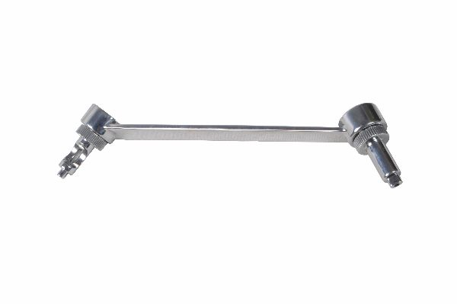
Function
The sleeve has two ends: the centric end centres the drill bit in the oval hole for a neutral screw position; the eccentric end offsets the drill 1 mm toward the fracture end, so when the screw is driven home, the rounded screw head gliding against the sloped hole rim translates the bone fragment toward the fracture for dynamic axial compression.
Advantages
Active Fracture Compression: The eccentric position generates controlled interfragmentary compression as each screw is inserted, creating the stable environment needed for primary bone healing without callus formation — the biological gold standard in clean transverse fractures.
Colour-Coded Identification: Most DCP sleeves are colour-coded or labelled 'N' (neutral) and 'L/R' (left eccentric / right eccentric), preventing sleeve selection errors that would misdirect compression away from the fracture line.
FAQ
Q: How many eccentric screws are needed for adequate compression?
A: One eccentric screw on each side of the fracture, drilled toward the fracture, generates approximately 300–400 N of interfragmentary compression — sufficient for most canine diaphyseal fractures.
Q: Can the DCP sleeve be used with locking plates?
A: No. Locking plates use a fixed-angle screw mechanism and require locking drill guides; DCP sleeves are only compatible with standard DCP oval holes.

ORTHOPAEDIC INSTRUMENTS
Basic Instruments for Small & Large Bone Plating
Drill Sleeve for Locking Plate (DCLP)
Intended Use
The DCLP drill sleeve is an angle-specific guiding instrument for locking plate systems that threads into the locking hole, precisely directing the drill at the plate-defined insertion angle. It is essential for correct locking screw placement in veterinary and orthopaedic surgery, particularly for periarticular and osteopenic bone fixation. | 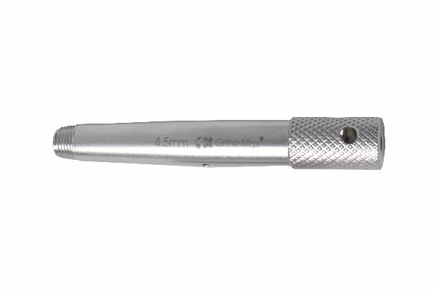
Function
The sleeve screws or clicks into the threaded locking hole of the DCLP, registering the drill bore at the exact angle encoded in the plate's locking hole. This ensures each locking screw thread engages fully with the plate's internal thread, creating the angle-stable construct that transfers load without screw-plate micromotion.
Advantages
Angle-Stable Construct Integrity: Correctly angled drill holes produced by the DCLP sleeve ensure locking screws engage in the precise axis designed by the plate manufacturer, achieving the full angular stability that makes locking plates superior in comminuted and osteopenic fractures.
Prevents Locking Hole Cross-Threading: If the screw does not enter at exactly the plate-defined angle, it cross-threads the locking hole and cannot be removed — a costly complication; the sleeve prevents this by defining the correct trajectory.
FAQ
Q: Why can't a standard drill guide be used with locking plates?
A: Standard guides do not match the specific locking hole angle; even minor deviation misaligns the screw thread with the plate's locking thread, preventing engagement and creating a loose construct.
Q: Is the DCLP sleeve universal across locking plate brands?
A: No — sleeve threading and angle vary by manufacturer; always use the matching sleeve from the same implant system to guarantee angular accuracy.

ORTHOPAEDIC INSTRUMENTS
Basic Instruments for Small & Large Bone Plating
Hexagonal Screwdriver with Quick Coupling Sleeve
Intended Use
The hexagonal screwdriver with quick coupling sleeve is a high-efficiency instrument for inserting and removing hex-socket orthopaedic screws during large bone plating. The quick-release mechanism allows rapid bit changes between drilling, tapping and screwing phases, improving operative efficiency in veterinary fracture surgery. | 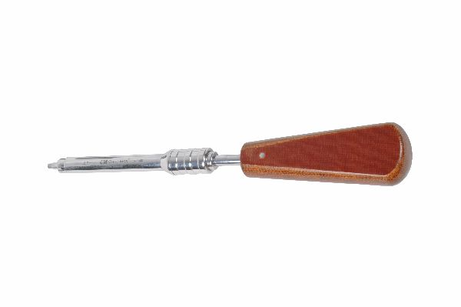
Function
The driver shaft carries a spring-loaded ball-lock mechanism in the coupling sleeve. Driver bits snap into the receiver with a click and are released by pressing the sleeve collar backward. The hex driving tip engages the screw head socket fully, providing high torque transmission without cam-out risk during final seating.
Advantages
Rapid Instrument Changeover: Quick-coupling allows the screwdriver tip to be switched from screwdriver to drill to depth gauge adaptor in under two seconds, keeping anaesthetic time to a minimum during multi-screw plating of large bone fractures.
High Torque Transmission: Full hexagonal engagement between driver tip and screw socket transmits torque uniformly, reducing cam-out that strips screw heads — particularly important for 4.5 mm cortical screws that require 2–3 Nm insertion torque.
FAQ
Q: What screw head sizes does the hex driver accommodate?
A: Standard veterinary plating sets use hex-socket screws sized 2.5 mm (for 3.5 mm screws) and 3.5 mm (for 4.5 mm screws); matching hex tip sizes must be used for each.
Q: Can the quick coupling sleeve be detached for separate sterilisation?
A: Yes. The sleeve is designed to separate from the shaft, allowing both components to be fully cleaned and autoclaved with internal coupling mechanisms accessible for instrument processing.

ORTHOPAEDIC INSTRUMENTS
Basic Instruments for Small & Large Bone Plating
Hexagonal Screwdriver
Intended Use
The standard hexagonal screwdriver is the primary torque delivery instrument for inserting hex-socket cortical and locking screws in small and large bone plating systems. It provides precise manual torque control essential for achieving correct screw seating without over-torquing and stripping bone threads in fracture repair. | 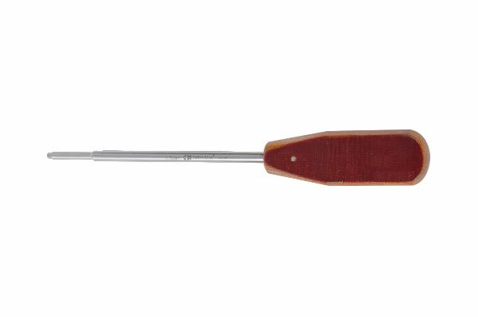
Function
A precisely machined hex tip engages the screw head socket fully. The surgeon applies rotational force through a contoured T-bar or palm-grip handle while maintaining axial alignment, advancing the screw into the tapped cortical hole until the screw head seates against the plate. The rigid shaft transmits tactile feedback signalling full engagement.
Advantages
Direct Tactile Control: Unlike power drivers, the manual hex screwdriver allows the surgeon to detect the subtle change in resistance at full screw seating, preventing over-torquing that strips threads in softer cancellous bone or in the small bone volumes of paediatric or small breed patients.
Universal System Compatibility: Hex-socket screws are the global standard for AO-compliant plating systems; a single set of hex drivers in 2.5 mm and 3.5 mm tip sizes covers the full range of 3.5 mm and 4.5 mm orthopaedic cortical screws.
FAQ
Q: What handle style is best for the hexagonal screwdriver?
A: T-bar handles allow bimanual torque for dense cortical bone; palm-grip handles offer more speed for multiple-screw constructs; surgeons often use both types during a single plating case.
Q: How do I prevent screw head stripping with a hex driver?
A: Ensure the hex tip fully seats in the screw socket before applying torque; even slight angulation between driver and screw causes point-loading that rounds the socket corners.

ORTHOPAEDIC INSTRUMENTS
Basic Instruments for Small & Large Bone Plating
Hollow Mill
Intended Use
The hollow mill is a cylindrical cutting instrument used in bone plating revision surgery to remove bone that has grown over an implant head or to expose a broken screw stub for retrieval. It is essential in implant removal procedures from healed fractures where bone overgrowth covers plate and screw heads. | 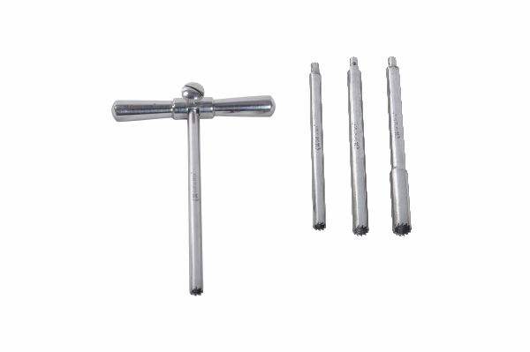
Function
A cylindrical bur with sharp, hardened cutting teeth on its leading rim is centred over the buried screw head using an alignment pin through the mill bore. When rotated by a T-handle, the teeth cut a clean circular channel through cortical bone overgrowth, exposing the screw head or broken stub without disturbing surrounding implant-bone interfaces.
Advantages
Precise Overgrowth Removal: The hollow mill removes exactly the bone column overlying the screw head, leaving adjacent cortex intact — critical for maintaining bone strength in active animals after plate removal to prevent post-operative fracture.
Enables Atraumatic Plate Removal: By exposing buried screw heads cleanly, the hollow mill converts a potentially damaging open bone removal into a controlled procedure that preserves the periosteum and cortex for accelerated post-removal remodelling.
FAQ
Q: What diameter hollow mill is used for 4.5 mm cortical screws?
A: 4.5 mm cortical screw heads require a 7–8 mm hollow mill; the mill diameter should be 2–3 mm larger than the screw head diameter to ensure full exposure.
Q: Can a hollow mill be reused?
A: Yes, but cutting teeth must be inspected before each case; a dull mill requires excess force that risks slipping off-axis and damaging adjacent bone.

ORTHOPAEDIC INSTRUMENTS
Basic Instruments for Small & Large Bone Plating
Multiple Diameter Gauge Scale 1–15 mm
Intended Use
The multiple diameter gauge scale is a comprehensive verification instrument covering 1–15 mm, used to measure the diameter of drill bits, wires, nails, rods and screws encountered across the full range of small and large bone plating and intramedullary implant procedures in veterinary orthopaedics. | 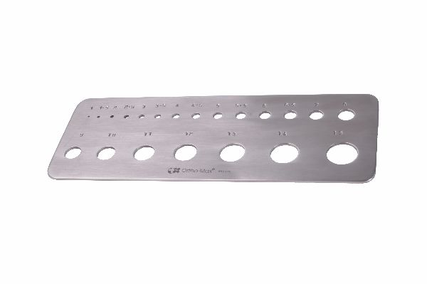
Function
A series of precisely machined holes in a flat stainless steel gauge plate, spaced at 0.5 mm or 1 mm increments from 1 to 15 mm, allows any cylindrical implant component to be slid through until it passes freely. The smallest passing hole identifies the component's diameter with high accuracy.
Advantages
Comprehensive Size Range: A single gauge covers implant diameters from fine K-wires (1 mm) through large intramedullary nails (15 mm), eliminating the need for multiple specialised gauges and simplifying the sterile instrument tray for complex combined fixation cases.
Quick Pre-Operative Verification: Scrub nurses can verify every implant diameter before handing off to the surgeon, preventing wrong-size drills or nails from being used — a critical safety step when multiple implant sizes are laid out simultaneously.
FAQ
Q: Is the 1–15 mm gauge accurate enough for orthopaedic purposes?
A: Precision gauges hold ±0.05 mm tolerance across the range, sufficient to differentiate between all standard AO implant sizes and prevent dangerous diameter mix-ups in clinical use.
Q: How should the gauge be cleaned?
A: Flush all holes with instrument cleaning solution under pressure, then autoclave upright to allow full water drainage; any residue in the holes affects measurement accuracy.

ORTHOPAEDIC INSTRUMENTS
Basic Instruments for Small & Large Bone Plating
Plate Bender – Roller Type
Intended Use
The roller-type plate bender is a contouring instrument that produces smooth, uniform curves in large bone plating implants. It is the primary tool for pre-operatively shaping broad reconstruction and compression plates to match the natural bone contour of large breed dogs and large animal orthopaedic patients. | 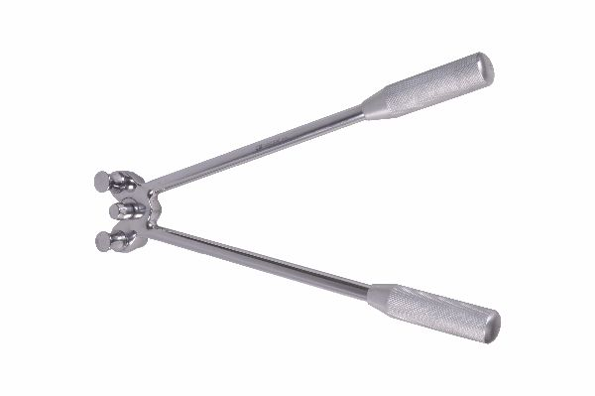
Function
Two parallel stainless steel rollers are set at an adjustable separation. As the plate is drawn between them and the rollers are compressed, the rollers cold-work the plate material into a uniform curve. Passing the plate through multiple times and progressively adjusting roller gap produces increasingly tight bends without creasing the plate.
Advantages
Smooth Uniform Curves Without Stress Risers: The roller mechanism distributes bending force across a wide plate segment, avoiding the localised metal stress that sharp-bend contouring creates; this preserves the plate's full cyclic fatigue life under prolonged weight-bearing in large dogs.
Reproducible Contouring: Roller separation settings allow semi-standardised contouring between patients with similar bone morphology, speeding plate preparation when matching a pre-selected plate to an anatomically normal contralateral limb template.
FAQ
Q: Can roller benders be used on titanium plates?
A: Yes, though titanium's higher springback requires greater over-bending than stainless steel to achieve the same final contour — account for approximately 10–15° of springback when setting final roller gap.
Q: Is it safe to bend locking plates with a roller bender?
A: Minimal bending only — excessive roller bending of locking plates distorts the threaded locking holes, preventing locking screw engagement and destroying the angle-stable construct.

ORTHOPAEDIC INSTRUMENTS
Basic Instruments for Small & Large Bone Plating
Plate Bender in Pair
Intended Use
Plate benders in pairs are hand-held contouring instruments used together to bend large orthopaedic plates by applying opposing forces at two controlled points. Working as a pair, surgeons or scrub staff can contour large stiff plates that a single bender could not adequately deform, enabling precise customisation of large plating implants. | 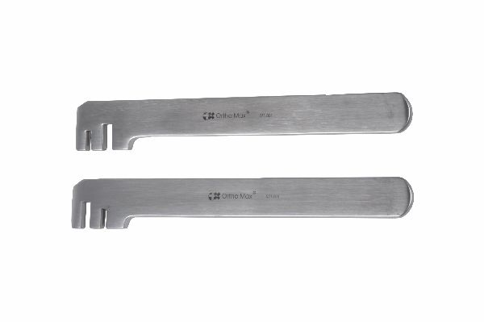
Function
Each bender engages a different plate hole with its notched jaw. The two instruments are then pivoted in opposite directions, applying a controlled three-point bending moment across the plate segment between them. Incrementally repositioning the pair along the plate allows full-length contouring to match the bone anatomy.
Advantages
Handles Large Stiff Plates: A single bender cannot generate sufficient force or control on broad 4.5 mm large bone plates; the paired instrument approach multiplies mechanical advantage and distributes force to produce clean, controlled curves without instrument slippage.
Precise Angulation Control: Two-point engagement gives the surgeon visual feedback on the angle applied at each step, allowing iterative adjustment and comparison against the bone profile until the plate fits without any rocking or gapping.
FAQ
Q: When should paired benders be used instead of a roller bender?
A: Paired benders are preferred for localised angular corrections and for bending around specific hole positions; the roller bender is better for producing smooth sweeping curves along the full plate length.
Q: How should the pair be held during bending?
A: One bender is held fixed as a fulcrum while the other applies the bending force; swapping which bender is the fulcrum allows bidirectional corrections at the same location.

ORTHOPAEDIC INSTRUMENTS
Basic Instruments for Small & Large Bone Plating
Reconstruction Plate Bender – Modified
Intended Use
The modified reconstruction plate bender is a specialised contouring instrument designed for the cross-cut reconstruction plates used in complex peri-articular and juxta-articular fracture repair. The modified design accommodates the transverse cuts in reconstruction plates that allow multi-planar bending. | 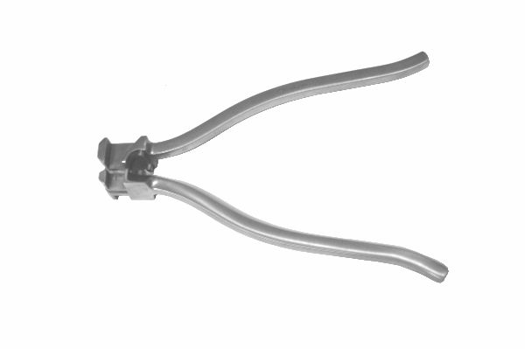
Function
Extended jaws span multiple plate segments, applying bending moments that exploit the flexibility provided by the transverse cuts. The modified jaw geometry prevents the cuts from opening excessively during bending, maintaining plate continuity while producing the complex three-dimensional contours needed for condylar and articular fractures.
Advantages
Multi-Planar Contouring Capability: Reconstruction plates must often be twisted as well as curved to match irregular articular bone surfaces; the modified bender allows simultaneous in-plane and out-of-plane deformation in a single instrument manoeuvre.
Preserves Transverse Cut Integrity: Standard benders can over-open the transverse slots, weakening the plate bridges; the modified jaw design limits slot opening during bending, maintaining the structural integrity of the bridging sections.
FAQ
Q: What fracture types require reconstruction plates?
A: Comminuted diaphyseal, peri-articular, and condylar fractures in the femur, tibia and humerus where standard straight or LC-DCP plates cannot achieve adequate contour without creating plate-bone gaps.
Q: How many times can a reconstruction plate be bent before it should be discarded?
A: Manufacturers generally recommend no more than three bending cycles; repeated deformation of the transverse cut bridges progressively reduces fatigue endurance.

ORTHOPAEDIC INSTRUMENTS
Basic Instruments for Small & Large Bone Plating
S.S. Scale Simple
Intended Use
The stainless steel simple scale is a basic measurement instrument used intraoperatively during bone plating to estimate plate length, bone segment dimensions, and wire or nail protrusion lengths. It serves as a rapid, autoclavable ruler on the sterile instrument tray for quick dimensional verification in veterinary orthopaedic surgery. | 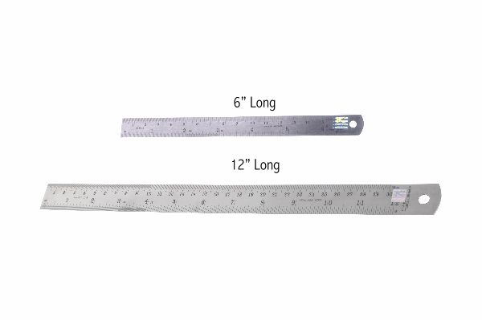
Function
A flat stainless steel ruler, typically 15–30 cm in length with engraved millimetre and centimetre graduations, is placed alongside the bone, plate or implant on the sterile field. Visual alignment of the scale with the bone ends or plate margins gives an instant length estimate to guide implant selection or confirm adequate plate overlap across the fracture zone.
Advantages
Immediate Sterile-Field Measurement: Having a dedicated sterile scale avoids the need to remove the patient from the table for radiographic measurement during surgery, shortening anaesthetic time and keeping the operative team focused.
Permanent Laser-Engraved Markings: Engraved graduations resist wear through hundreds of autoclave cycles, maintaining legibility and accurate readings throughout the instrument's operational life in busy surgical environments.
FAQ
Q: Can the SS scale be used for radiographic measurement?
A: On plain radiographs, the scale can be placed alongside the limb as a magnification reference marker, allowing the radiographer to calculate true bone dimensions and accurately size implants from the films.
Q: What length SS scale is most practical for bone plating?
A: A 30 cm scale covers most plating applications from small breed tibial fractures to large breed femoral plating, while remaining compact enough for the sterile instrument tray.

ORTHOPAEDIC INSTRUMENTS
Basic Instruments for Small & Large Bone Plating
Universal Bone Drill
Intended Use
The universal bone drill is a versatile hand-powered drilling instrument compatible with the full range of drill bit diameters used across small and large bone plating systems. Its adjustable chuck accepts bits from 1.5 mm to 6.0 mm, making it the single go-to drilling instrument for multi-size plating cases in veterinary fracture surgery. | 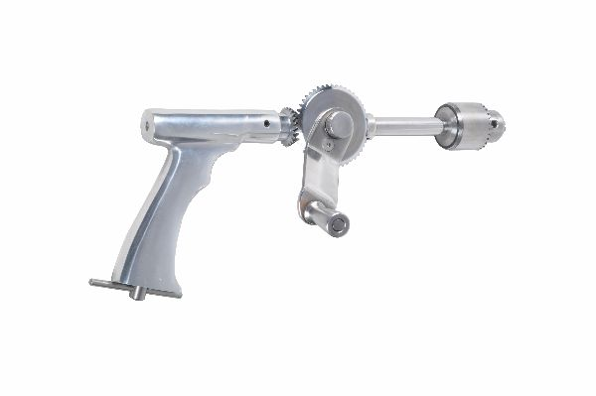
Function
A precision keyless or keyed chuck grips any standard round-shank drill bit. The T-bar or cross-handle transmits manual rotational force to the chuck. Gear reduction options in some models multiply torque for cortical drilling of large bones while maintaining controlled speed for thermal protection of bone around the drill hole.
Advantages
Single-Instrument Versatility: One universal drill replaces separate drills for mini, small, and large bone plating systems, streamlining the instrument tray, reducing sterilisation load and simplifying theatre preparation for mixed fracture case lists.
No Power Source Required: Hand operation eliminates dependence on pneumatic lines or electrical power, making this drill essential in field surgery settings, mobile orthopaedic units and low-resource veterinary facilities.
FAQ
Q: Can the universal drill be used with 4.5 mm drill bits for large bone plating?
A: Yes. The chuck accommodates up to 6.0 mm shank diameters, covering the 4.5 mm and 5.0 mm bits used in large cortical bone drilling for canine femur and tibia plating.
Q: How is the chuck maintained?
A: Lubricate the chuck mechanism with surgical instrument oil after cleaning, inspect for jaw-wear that could allow drill-bit slip, and confirm jaw closure force before each sterilisation cycle.

